**Mykhailo Teliatnikov**

**Date of birth:**

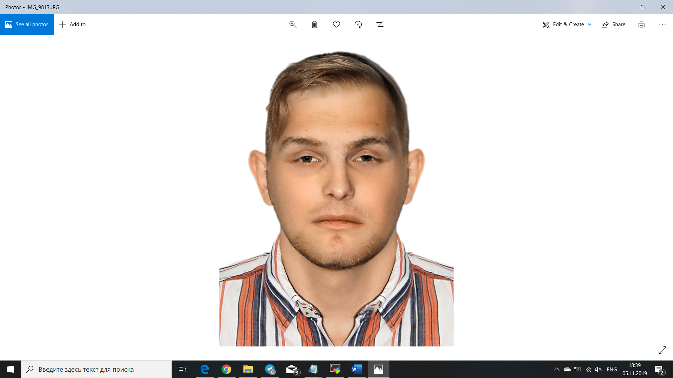

28.08.2000

**Place of residence:**

Kharkiv

**Phone number:**

0970425605

0973787845

**E-mail:**

[mihanik.dr28@gmail.com](mailto:mihanik.dr28@gmail.com)

[m.teliatnikov@student.csn.khai.edu](mailto:m.teliatnikov@student.csn.khai.edu)

**My repository:**

project <https://github.com/Krotym/test>

dockerfile https://github.com/Krotym/Dockerfile

**About me:**

Student in KHAI on specialty:

“Computer engineering”

Directions:

“System programming”.

Finished college HRTK (2015-2019).

Specialty:

“Service computer systems and networks”;

**Languages programming:**

- Pascal (elementary);

- C++/C# (medium);

- JavaScript (elementary);

- PHP (elementary);

- Assembler (elementary);

**Technologies/Instruments:**

- Linux/Windows (medium);

- Bash (medium);

- PowerShell (elementary);

- AWS (elementary);

- Jenkins (medium);

- Ansible (medium);

- Git (elementary);

- Docker (medium);

**Additional skills:**

- Create 3D models in application Blender;

- MS Word\Excel (medium);

- English level – A2 ;

- Ability create board at ready drawings **+** ability soldering different components (wire-chip);